Chapter 4, Solution 47

Obtain the Thevenin and Norton equivalent circuits of the circuit in Fig. 4.114 with respect to terminals a and b.

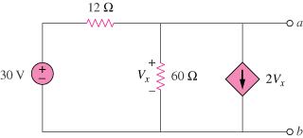

Figure 4.114
For Prob. 4.47.

Solution

Since V_{Th} = V_{ab} = V_{x}, we apply KCL at the node a and obtain

To find R_{Th}, consider the circuit below.

12 V_{x} a

2V_{x}
60
1A

At node a, KCL gives
Thus,

V_{Thev} = 1.1905 V, R_{eq} = 476.2 mΩ, and I_{N} = 2.5 A.

